SF.SmokeTestScripts_TC_SF_OBRequiredFieldsOnSalesStage_Instance1_12-Apr-2017_10-43-14_PM_Invoke_Application.png



SF.SmokeTestScripts_TC_SF_OBRequiredFieldsOnSalesStage_Instance1_12-Apr-2017_10-43-30_PM_Login.png

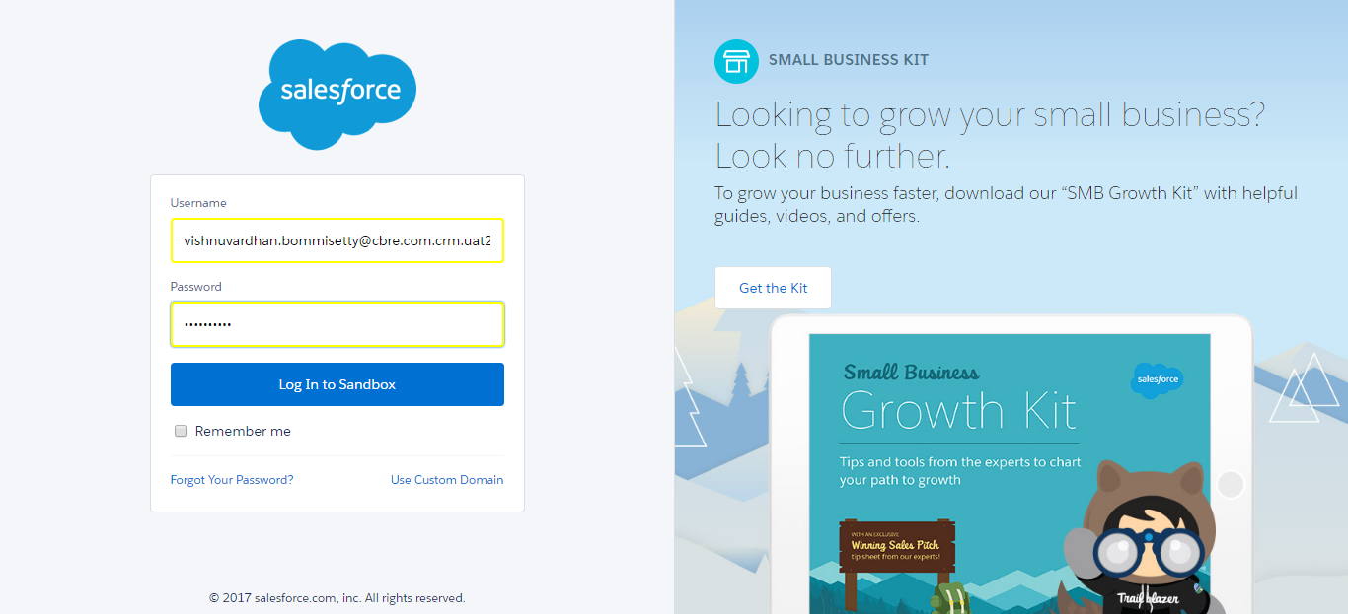

SF.SmokeTestScripts_TC_SF_OBRequiredFieldsOnSalesStage_Instance1_12-Apr-2017_10-43-45_PM_Verify_Login.png

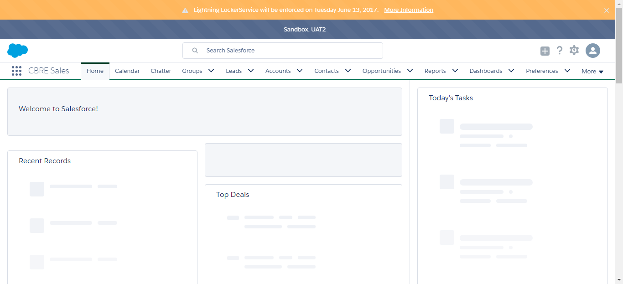

SF.SmokeTestScripts_TC_SF_OBRequiredFieldsOnSalesStage_Instance1_12-Apr-2017_10-43-48_PM_Verify_Fetch_Record.png

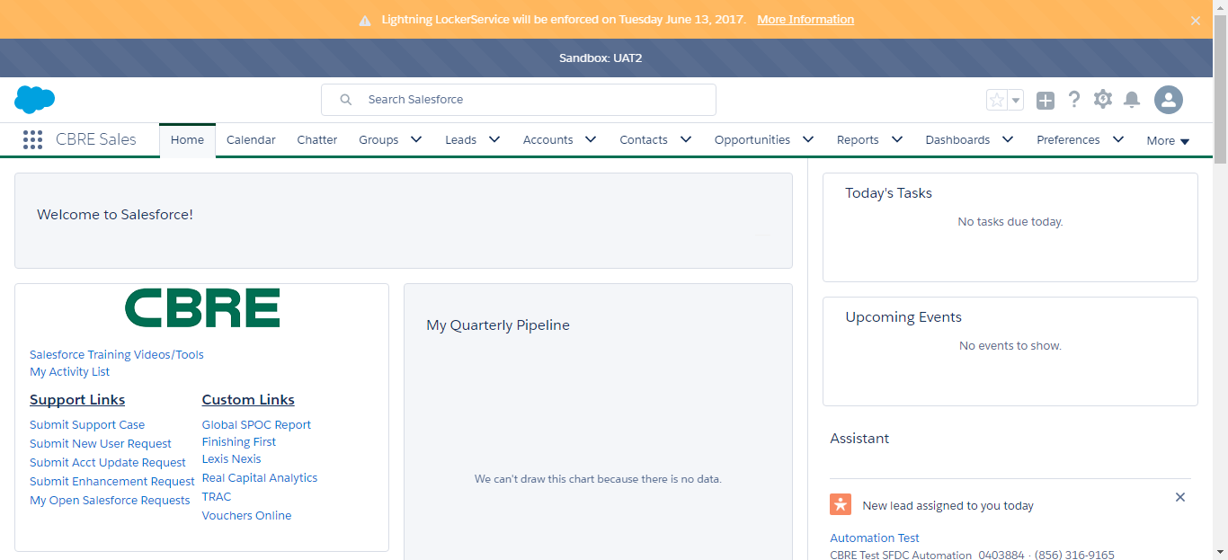

SF.SmokeTestScripts_TC_SF_OBRequiredFieldsOnSalesStage_Instance1_12-Apr-2017_10-43-52_PM_Verify_Add_Opportunity_Page



SF.SmokeTestScripts_TC_SF_OBRequiredFieldsOnSalesStage_Instance1_12-Apr-2017_10-43-52_PM_Verify_Opportunity_Required



SF.SmokeTestScripts_TC_SF_OBRequiredFieldsOnSalesStage_Instance1_12-Apr-2017_10-44-12_PM_Verify_Add_Opportunity_Page

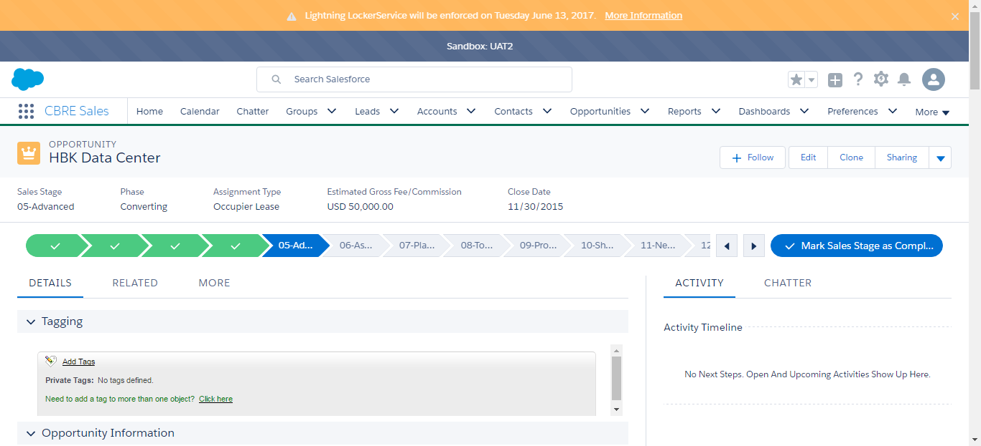

SF.SmokeTestScripts_TC_SF_OBRequiredFieldsOnSalesStage_Instance1_12-Apr-2017_10-44-50_PM_Error.png

